**DAY 0 [15/01/2022]: Introduction**

**1.What is Machine Learning?**

**Machine Learning is a field of Computer Science that uses statistical to give computer systems the ability to "learn" with data without explicitly programmed.**

**In simple words, Machine learning is all about learning from data. In normal programming languages we write code for every scenario, but in machine learning we have got some data and algorithms. Algorithms analyse the data and create patterns between the input and output. As we get to know the patterns, we give the input data and fetch the output.**

**[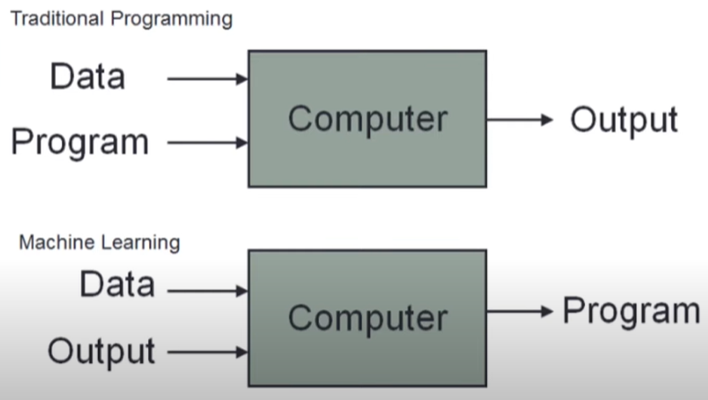](https://user-images.githubusercontent.com/79328907/149609256-1896ce60-a0be-4da4-8d1d-211242a84d08.png)**

**In conventional programming, we create a logic by writing the program and further we give the input and get the output. But in machine learning, logic is generated automatically by the algorithm henceforth need not to write the program.**

**We need not to write code for each and every condition/ case, it will be handled automatically by the ML algorithm.**

**Example:**

**Let’s say, we have written a programme for addition of two numbers. As we give two numbers as input, it will give the sum. But in ML, we give the data as excel sheet which consists of numbers and the sum of each row. The machine learning algorithm train the data and analyse that the pattern is addition. As in future, if we input as two or three or more numbers, it will do the sum by default. But in the programme that we have written, if we give three or more numbers, the programme wont work as it is explicitly coded to perform the sum of only two numbers. This is the main difference and reason why the machine learning has become more powerful in today’s era.**

**2.Scenerios where machine learning is most important:**

**1.Scenerio where programme cannot be written for every case.**

**Ex: Email Spam Classifier.**

**As a programmer, we have to write a code for classifying email into span or not spam. For this, we collect many emails, and we try to create pattern as for example, more than three times ‘huge’ or ‘sale’ or other words have been used. For different conditions, using if we create a long if else statements and that will be a programme to identify the particular incoming email is spam or not.**

**But let’s say, if ‘*huge*’ word is written more than three times, we would label that email to be spam. But somehow the advertising companies get to know that the email client where code has been written, they get to know about this spam listing of emails with ‘huge’ word in it. Hence what they can do is, instead of writing ‘*huge*’ they would write ‘massive’, ‘big’ or any other words. Now our programme won’t be able to handle this condition, unable to include it in the spam. Thus, we need to change the logic of the program again. But the advertising companies would come to know this again. So we would be required to change the code several times which is not efficient.**

**But this is not the case in machine learning. Since we are training the data, as the data changes logic also changes. This is the beauty of machine learning. We have to write just one algorithm and everything will be handled by that algorithm.**

**2.Scenerio where there are many cases that cannot be handled by normal conventional programming.**

**Ex: Image Classification**

**There are several thousand breeds of dogs with different colour, height and other features. Incorporating each and every breed in a program is impossible. We have to use the logic how humans identify them by different features. This is one scenario where programs cannot be written using native software development, we will have to use machine learning.**

**3.Data Mining**

**Data analysis is process where we fetch the hidden information or pattern and plot it in a graph or any other. But sometimes, the information will be hidden in depth such that by plotting the graph it won’t be visible.**

**For example, from which keyword the email goes to spam? To get to know this, we do data mining.**

**In data mining what we do is, by passing data over ML algorithm, we create a prediction model. Now we can go back and see which pattern does the machine learning model has seen. As in spam classifier, we would get to know from which words does that email has been included in spam.**

**Therefore, from the information we have got after machine learning if we fetch stuffs regarding the data then it is known ad Data Mining.**